Kingdom Divided
“Elijah, Ravens, and a Widow”

Series Objective:
Students will learn:
- The Kingdom of Israel divided after Solomon’s death
- Elijah called the kings and people of Israel back worship of God
- The story of Josiah, one of Judah’s good kings

Series Theme Verse: “Elijah went before the people and said, ‘How long will you waver between two opinions? If the Lord is God, follow him.’” – 1 Kings 18:21
Lesson Objective: For students to understand that God used prophets (Elijah) to speak to the two kingdoms and guide them back to worship of God, on an individual and community basis.

Lesson Passage: 1 Kings 17:2-9, 17-24

Materials Needed: Bibles, Bean Bags, Muffin Mix, pictures of meat, pictures of bread, Series Theme Verse cut into pieces

Lesson Plan:
Talking Points: 1 Kings 17:2-9

- Who spoke to Elijah? (The Lord)
- What did the Lord say to Elijah? (Leave and hide in the Kerith Ravine)
- You might need to explain to students what a ravine is. Explain to students that Elijah was sent into hiding to protect him from King Ahab who did not like Elijah.
- How would Elijah survive in the ravine? (Drink from the stream, ravens would bring him food)
- Did Elijah do as God said, even though the plan sounded odd, especially being fed by birds? (Yes)
- What happened the first morning Elijah was in the ravine? (Ravens brought him bread and meat each morning and evening to eat)
- What eventually happened to the stream? (It dried up because there had been no rain)
- When the stream dried up, what did God say to Elijah? (Go to the town of Zarephath and a widow, or lady whose husband has died, will feed you)

Talking Points: 1 Kings 17:17-24

- While Elijah was being taken care of by the widow, what happened? (Her son became sick and died)
- What did the widow think in the midst of her pain at losing her son? (Did you, Elijah, cause this because of my sins, the bad things I have done?)
- What did Elijah say to the widow? (Give me your son)
- When she gave Elijah her son, what did Elijah do? (Carried him to the upper room and prayed to God to bring the son back to life)
- Did the Lord do as Elijah asked? (Yes, the boy came back to life)
- When the widow was given back her living son, what did she say? (She knew that Elijah was truly a prophet of God, one who spoke for God)

The Story Retold:
- Feeding Elijah – Option 1
  - Place pictures of bread and meat around the room on the floor.
  - Divide students into two or three teams.
  - Each team receives a bean bag and must toss the bean bag on a picture of bread or a picture of meat.
  - If the first team to go lands their bean bag on a picture of meat, they receive that picture and on their next turn, they are trying for bread.
  - First team to collect a picture of bread and a picture of meat to feed Elijah wins.
  - Use the game to reinforce God’s provision for Elijah in a miraculous way.
- Feeding Elijah – Option 2
  - Bring some muffin mixes to class and have students help make the muffins (You can do this to start class so they cook and cool while the lesson is going).
  - Let students eat the muffins and use the muffins to reinforce God’s provision of food for Elijah in such a miraculous way.

The Story and Me:
- Have the Series theme verse written on a poster or white board.
- Have the students read the verse together.
- Using the bean bags from earlier, have the verse cut into large pieces scattered on the floor.
- Have students toss bean bags at pieces of the verse to collect and put the pieces together.
- Say the verse together.
- Remind students that because of Elijah’s healing of the widow’s son, she believed in God and who Elijah was.
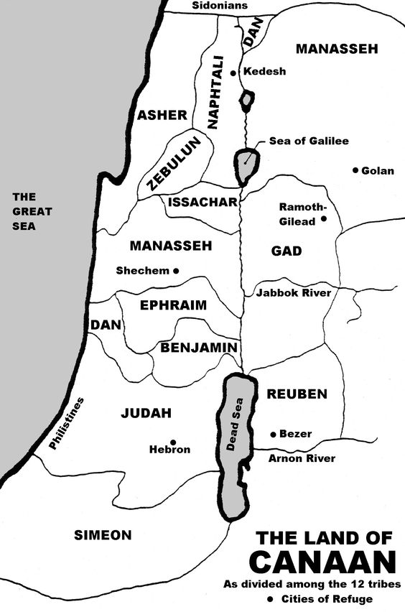
Mt. Carmel

